## **Python Coding Challenge - Day 8 (18-06-2025)**

## **Topic: List, Tuple, Dictionary, Set | Total Questions: 10 | Time: 60 minutes**

## Q1. **Remove all duplicates from a list without using set()**

nums = [1, 2, 2, 3, 4, 4, 5]

unique = [ ]

for num in nums:

if num not in unique:

unique.append(num)

print(unique)

**OUTPUT :** 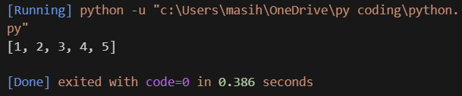

## **Q2. Find the second highest unique number in a list**

nums = [12, 5, 9, 21, 21, 3]

unique = [ ]

for num in nums:

if num not in unique:

unique.append(num)

unique.sort(reverse=True)

print(unique[1])

**OUTPUT :** 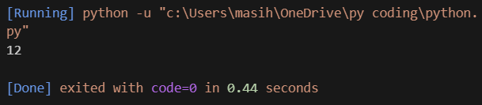

## **Q3. Rotate a list to the right by k positions**

list = [1, 2, 3, 4, 5]

k = 2

k = k % len(list) # Handle if k > length

rotated = list[-k:] + list[:-k]

print(rotated)

**OUTPUT** 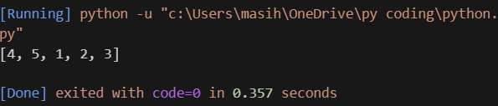

## **Q4. Multiply elements of each tuple in a list and return a new list**

tuples = [(2, 4), (3, 5), (4, 6)]

result = [ ]

for a, b in tuples:

result.append(a * b)

print(result)

**OUTPUT**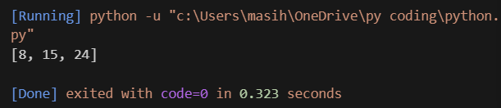

## **Q5. Count how many times each element occurs in a tuple**

data = (1, 2, 2, 3, 1, 4, 2)

count = { }

for num in data:

if num in count:

count[num] += 1

else:

count[num] = 1

print(count)

**OUTPUT**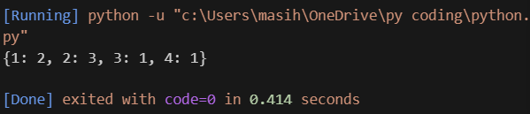

## **Q6. Count the frequency of each character in a string using a dictionary**

text = 'banana'

freq = { }

for char in text:

if char in freq:

freq[char] += 1

else:

freq[char] = 1

print(freq)

**OUTPUT**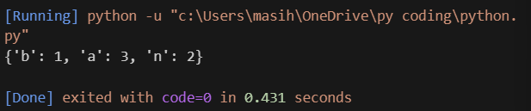

## **Q7. Merge two dictionaries with value sums for common keys**

dict1 = {'apple': 10, 'banana': 5}

dict2 = {'banana': 3, 'orange': 7}

result = dict1.copy() # Start with the first dictionary

for key in dict2:

if key in result:

result[key] += dict2[key] # Sum values if key exists

else:

result[key] = dict2[key] # Add new key

print(result)

**OUTPUT** 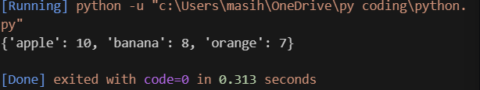

## **Q8. Print name(s) of student(s) with the highest marks**

marks = {'Alice': 85, 'Bob': 92, 'Carol': 92}

highest = max(marks.values()) # Find the highest mark

top_students = [ ]

for name, score in marks.items():

if score == highest:

top_students.append(name)

print(top_students)

**OUTPUT**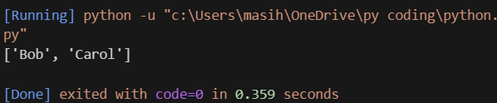

## **Q9. Find all common elements among 3 lists using set operations**

list1 = [1, 2, 3]

list2 = [2, 3, 4]

list3 = [3, 2, 5]

common = set(list1) & set(list2) & set(list3) # Set intersection

print(common)

**OUTPUT**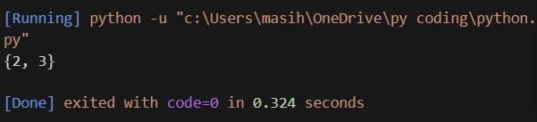

## **Q10. Extract and display all unique words from a sentence**

sentence = 'this is a test this is fun'

words = sentence.split()

unique_words = set(words)

print(unique_words)

**OUTPUT**